Project Plan
Document Number: 01
Date: Day, Month Day, Year
KnowledgeBridge
Andrew McDaniel
Ethan Gregg
Luis Ayala
Dylan Taussig
Adrian Edwards

Client: Pravin Khandke

This form must be completed in accordance with the Software Engineering Body of Knowledge (SWEBOK).

Table of Contents
Introduction 2
1. Project Overview 3
1.1 Scope 3
1.2 Current System or Situation 5
1.2.1 Background, Objectives, and Scope 5
1.2.2 Operational Policies and Constraints 6
1.2.3 Description of Current System or Situation 7
1.2.4 Users or Involved Personnel 10
1.3 Standards to follow 10
2. Development Background/Approach 11
2.1 High Level Estimates 11
2.2 Key Contacts and Stakeholders 11
3. Features, Primary Deliverables, and External Commitments 12
3.1 Feature List 12
3.2 Customer Deliverables 13
4. Project Schedule 15
4.1 Major Project Milestones 15
4.2 Project Status Tracking & Working Meeting Minutes 15
5. Project Work and Product Estimates 15
5.1 Estimate Summary 15
6. Project Resource Requirements 16
6.1 Staffing/ Skill Requirements 16
6.2 Plan to Fill Skill Gaps 17
7. Dependencies and Constraints 17
7.1 Constraints 17
8. Risk Management 17
8.1 Risk Management Strategy 17
8.2 Initial Risk List 18
9. Project Configuration and Data Management 19
9.1 Configuration Management 19
10. Project Process 20
10.1 Software Life Cycle Model 20
11. Referenced Documents 21
12. Glossary 22
13. Change Record 25
14. Appendices 26

Introduction
This Project Plan describes the scope, context, stakeholders, activities, resources, schedule, constraints, risks, quality goals, and processes. It is intended to provide a guide to how development work will be managed.

KnowledgeBridge is a one-semester software engineering capstone project focused on the design, implementation, and evaluation of an AI-powered business knowledge management platform. The product will provide organizations with a centralized way to ingest, organize, manage, and retrieve company-specific knowledge that may otherwise be fragmented across documents or dependent on individual employees. Authorized personnel will be able to add and manage knowledge sources, while end users will be able to search the indexed content or ask questions through a natural-language interface. The system will return answers grounded in the organization's source material, provide citations or links to the supporting sources, and clearly indicate when the available information is insufficient to produce a reliable answer.

KnowledgeBridge will be developed as a browser-based, full-stack application using React for the user interface, Spring Boot for the application layer, PostgreSQL for data storage, and GBrain as an external knowledge engine supporting retrieval-augmented generation, vector search, and keyword search. The project will prioritize a stable end-to-end proof of concept that demonstrates knowledge ingestion, indexing, management, retrieval, cited answer synthesis, and knowledge-gap handling. In addition to producing working software, the team will evaluate the reliability, limitations, estimated operating costs, and appropriate role of human oversight when AI is used to retrieve and summarize business knowledge. The project is not intended to produce a production-scale enterprise system, but rather to demonstrate the technical feasibility and practical value of an AI-assisted organizational knowledge platform.

Project Overview

Scope

Identification
The system covered by this document is identified as Capstone Project 07, KnowledgeBridge: AI-Powered Business Knowledge Management Platform. The shortened system name used throughout this document is KnowledgeBridge. This document is the KnowledgeBridge Software Project Plan, identified as Document Number 01.

This plan applies to the initial KnowledgeBridge MVP and prototype being developed during the Fall 2026 semester. A formal commercial product version or release number has not been assigned. For project planning purposes, the software described in this document is considered the initial capstone release of KnowledgeBridge. Future versions, releases, or post-capstone development are outside the scope of this document unless they are later added through the project's change-control process.

The software covered by this plan includes the React-based browser interface, the Java and Spring Boot application layer, PostgreSQL and pgvector data storage, integration with GBrain through its available service interfaces, Docker and Docker Compose configuration, and the related project documentation, test data, and evaluation materials. External large language model, embedding, hosting, and source-control services are treated as project dependencies. These external services are not being developed by the student team.

System Overview
KnowledgeBridge is a browser-based business knowledge management application intended to help an organization collect, organize, search, and use company-specific knowledge. Business information is often spread across documents, shared folders, meeting notes, emails, and the knowledge of individual employees. This makes the information difficult to find and creates the possibility that important knowledge will be lost, duplicated, or become outdated. KnowledgeBridge is intended to provide a central interface through which authorized users can add and manage knowledge sources and other users can search the available information or ask questions in natural language.

The system will use GBrain as an external knowledge engine to support document ingestion, content indexing, hybrid retrieval, and answer synthesis. The application will support traditional keyword search and vector-based semantic search. When synthesis is requested, the system will provide an answer based on the stored knowledge and include citations or references to the supporting source material. The interface should also communicate when the available sources do not contain enough information to answer a question confidently. This is important because the system uses AI-generated output, which may be incorrect, incomplete, or misleading when the underlying evidence is weak.

KnowledgeBridge is planned as a full-stack web application. React will be used for the browser-based user interface, while Java and Spring Boot will provide the main application and API layer. PostgreSQL, including the pgvector extension where needed, will store application data, document metadata, cached responses, vector data, and other supporting information. GBrain will operate as a separate service rather than being modified directly by the student team. The complete development environment is expected to use Docker and Docker Compose so that the required services can be started consistently on the team members' development computers. Git and GitHub will be used for source control, issue tracking, collaboration, and delivery of the project repository.

The project began as a one-semester Fall 2026 undergraduate capstone project. The project kickoff meeting was held on August 31, 2026, to introduce the participants, discuss the proposed architecture, identify the initial MVP, and establish the first development activities. At the time of this plan, KnowledgeBridge is in the planning, requirements, environment-setup, and early development stages. The system has not previously been released, operated in production, or maintained as a deployed business application. During the capstone semester, the student development team will be responsible for implementation, testing, documentation, demonstrations, and correction of defects found during development. Responsibility for operation or maintenance after the capstone semester has not yet been assigned.

The project sponsor, client, and primary technical contact is Pravin Khandke of the Department of Information Technology. No separate external acquirer has been identified. For the purposes of this project plan, the sponsor and client will be treated as the acquiring stakeholder who reviews the project, provides technical guidance, and accepts the capstone deliverables. The primary users of the proposed system are organizational administrators or knowledge managers who add and manage content, and business users who search the knowledge base or ask questions through the query interface.

The student development team consists of Andrew McDaniel, Ethan Gregg, Luis Ayala, Dylan Taussig, and Adrian Edwards. Andrew McDaniel is the identified student project leader. Kennesaw State University capstone faculty, coordinators, and facilitators provide academic oversight, scheduling support, process guidance, and assistance with sponsor communication. The sponsor will also provide or identify technical information related to GBrain, its supported interfaces, and the expected deployment environment.

Current development will take place on the team members' local computers using the shared GitHub repository and containerized development services. The application itself will be accessed through a desktop web browser. The final demonstration may run on a team member's local system, a virtual machine, a shared test environment, or another sponsor- or university-approved environment. The permanent hosting and post-project operating site have not been selected at the time of this plan.

Relevant documents include the 07-KnowledgeBridge AI-Powered Business Knowledge Management Platform-IND project specification, this Software Project Plan, and the approved project requirements and scope baseline once completed. Other relevant documents will include the system architecture diagram, business knowledge workflow diagram, user-flow diagrams, interface documentation, test plan, test results, deployment instructions, user documentation, cost analysis, reliability evaluation, and final feasibility report.

Document Overview
The purpose of this Software Project Plan is to explain how the KnowledgeBridge project will be organized, managed, developed, tested, and delivered. It provides a common planning reference for the student development team, project sponsor, faculty, and capstone coordination personnel. The plan is intended to keep the project focused on an achievable MVP, make responsibilities and expectations clear, and provide a basis for tracking progress throughout the semester.

This document describes the project scope, current situation, background, objectives, users, applicable standards, and overall development approach. It also includes high-level estimates, key contacts and stakeholders, the planned feature set, customer deliverables, major milestones, status-tracking procedures, staffing and skill requirements, project dependencies, constraints, risks, configuration-management practices, and the selected software life-cycle approach. The final sections provide references, definitions of important terms, and a record of changes made to the plan. Detailed requirements, architecture decisions, test procedures, and user instructions may be maintained in separate documents and referenced by this plan rather than repeated in full.

This document is intended for use by the project team, sponsor, faculty, and other authorized capstone personnel. It is not expected to contain classified information, but it may include team contact information, repository information, system architecture details, risk information, cost assumptions, and descriptions of the planned development environment. Passwords, API keys, authentication tokens, private encryption keys, and other secrets shall not be included in this document or committed to the source repository.

KnowledgeBridge is intended to process organizational information, which could include proprietary business knowledge or personal information in a real deployment. During capstone development and testing, the team will use synthetic, public, or otherwise non-sensitive test content. Real confidential business information should not be uploaded unless its use has been specifically approved and the required security and privacy controls are in place. The team should also consider data minimization, secure configuration of external AI services, deletion of indexed content and embeddings, and the possibility that information sent to an external model provider may leave the locally controlled environment. Any later change involving sensitive data, authentication requirements, external hosting, or expanded access should be reviewed with the sponsor before it is implemented.

Current System or Situation
The current situation is not a single integrated software system. Instead, business knowledge is stored as a collection of documents that users search and review manually. A user who needs a specific piece of information normally performs a keyword search within a shared drive, document repository, local file system, or similar storage location. If the correct keywords are unknown or the search results are not useful, the user manually browses folders, opens possible documents, and reads through them until the needed information is found. In some cases, the user may also ask another employee who is familiar with the documents or subject area. This section describes that manual document-retrieval process as the baseline that KnowledgeBridge is intended to improve.

Background, Objectives, and Scope
Organizations create and collect a large amount of internal knowledge over time. This knowledge may include policies, procedures, meeting notes, technical documentation, project decisions, training materials, and other business records. Even when the documents are stored electronically, the information may still be difficult to locate because it is spread across folders, file formats, repositories, and naming conventions. Users may know that the information exists without knowing its exact location, title, author, or wording. New employees are especially affected because they may not understand how the documentation is organized or which terms were used when a document was written.

The current system's main objective is to store business documents and allow authorized users to locate and read them when information is needed. It provides a basic way to preserve written knowledge and share it among employees. Keyword-search features may help narrow the document collection, while folder structures and filenames provide a way to organize and browse the files. The user is responsible for deciding what to search for, determining which results appear relevant, opening the documents, locating the useful passages, comparing conflicting information, and deciding whether the information is current and reliable.

The scope of the current situation includes the existing document corpus, its folder or repository structure, the search features provided by the file-storage platform, and the manual procedures used by employees to locate information. It also includes informal knowledge retrieval, such as asking a coworker to identify a document or explain where information is stored.

The current system does not provide semantic or meaning-based search across the entire documentation corpus. It does not accept a natural-language question and generate a direct answer from multiple documents. It also does not automatically combine related information, identify knowledge gaps, resolve duplicate or outdated content, explain why one source should be trusted over another, or provide a synthesized answer with supporting citations. Traditional search generally returns documents that match the user's keywords, leaving the user to examine the results and form an answer manually. The KnowledgeBridge project specification identifies fragmentation, difficulty discovering information, dependence on individual employees, and the lack of on-demand answers as major problems with the current situation.

Operational Policies and Constraints
No separate set of operational policies for a named legacy system has been provided for this project. Therefore, this plan assumes that the current manual process follows the policies of the organization and the file-storage systems already in use. Users are expected to access only the documents for which they have permission. Existing folder permissions, user accounts, shared-drive permissions, and document-management controls determine who may view, edit, copy, or delete each file.

Document owners, authors, or department personnel are generally responsible for creating and updating the documentation. Users performing a search are responsible for checking the document title, author, revision date, version number, and other available metadata before relying on the information. When multiple documents provide different answers, the user must manually decide which source is newer or more authoritative. Important operational or business decisions should not be based only on an unverified search result. The user may need to confirm the information with a supervisor, subject-matter expert, document owner, or other responsible person.

The current situation is subject to several operational constraints:

- Keyword search depends on the user selecting terms that appear in the document. A search may fail when the document uses different terminology, abbreviations, synonyms, or older names.
- Search quality depends on whether the repository can index the document's file type and contents. Scanned documents, images, unusual formats, or damaged files may not be fully searchable.
- Folder browsing depends on consistent naming and organization. Inconsistent filenames, duplicate copies, deep folder structures, and documents saved in unexpected locations increase search time.
- The process depends heavily on user knowledge. Experienced employees may know where information is stored, while new employees may not know the correct folder, filename, project name, or keyword.
- The user must read and interpret the search results manually. The system returns possible files rather than a verified answer.
- There may be multiple versions of the same document, and the current process may not clearly identify which version is approved or current.
- Search is limited to repositories and folders that the user can access. Information stored in another system, an employee's local computer, an email account, or an undocumented conversation may not appear in the results.
- The availability of the process depends on the availability of the storage platform, network connection, device, and user account.
- Security and privacy depend on the configuration and use of the existing repositories. Copies downloaded, emailed, or moved outside the approved repository may no longer be protected by the original access controls.
- Search results do not guarantee that the information is complete, correct, current, or appropriate for a particular business decision.

These constraints become more significant as the document collection grows. Adding more files may preserve more knowledge, but it also creates more search results, duplicate content, outdated material, and information that must be reviewed manually. The project background specifically notes that business knowledge may be fragmented across multiple systems, become stale, and remain dependent on employees who know where the information is located.

Description of Current System or Situation
The current situation does not have formally defined system states or operating modes. The same general search and browsing process is used during normal work, training, maintenance, or other activities. When the primary repository or network is unavailable, users may rely on locally saved copies, previously downloaded documents, printed materials, or information obtained from another employee. This is not a formally designed degraded mode, and the amount of information available under those conditions may be limited.

Operational Environment
The current process normally takes place on a desktop or laptop computer using a file browser, shared-drive interface, document-management website, or built-in search tool. Documents may be stored on a local drive, network share, cloud storage platform, shared team folder, or another electronic repository. The user may use a web browser or file-management application to search for documents and then open the selected files using applications such as a word processor, PDF reader, text editor, spreadsheet program, or presentation viewer.
The operational environment may include both local and remote users. Remote users depend on network access, account authentication, and any required virtual private network or cloud-service connection. Search capabilities may differ between repositories, so a user may need to repeat the same search in several locations.

Major Components and Interconnections
The major components of the current situation are:
- Documentation corpus: The collection of policies, procedures, notes, reports, technical files, project records, and other documents that contain the organization's written knowledge.
- Storage repositories: The local folders, shared drives, cloud folders, document-management systems, or other locations where the files are stored.
- Folder and naming structure: The directories, filenames, document titles, tags, and metadata used to organize the files.
- Keyword-search function: The search feature provided by the operating system, file repository, or document-management platform. Depending on the platform, it may search filenames, metadata, document contents, or a combination of these.
- Document-viewing applications: The applications used to open, read, and sometimes edit the documents.
- Users and subject-matter experts: The employees who perform searches, interpret results, maintain documents, or assist other users in finding information.
The components are connected through a mostly manual workflow. The repository stores the documents, the search feature examines indexed filenames or content, and the user reviews the returned results. The document-viewing application displays a selected file, but the user must locate and interpret the useful information within it. If the information cannot be found, the user repeats the search, browses additional folders, or contacts another person.

Interfaces to External Systems and Procedures
The current process may interface with several external tools and procedures, including file-storage platforms, operating-system search tools, document editors, email, messaging systems, and organizational approval processes. For example, a user may find a possible answer in a document but still need to contact the document owner through email or chat to confirm that the information is current.
There is no single interface that searches every possible source of business knowledge. A user may need to search a shared drive, then search email, then browse project folders, and finally ask a coworker. Information that has never been documented cannot be retrieved through the document-search process.

Current Capabilities and Functions
The current situation supports the following basic functions:
- Storing documents in electronic folders or repositories.
- Organizing documents using folder structures, filenames, and basic metadata.
- Searching filenames and, where supported, indexed document text.
- Filtering or sorting files by attributes such as date, type, owner, or location.
- Opening and reading documents.
- Copying, downloading, printing, editing, or sharing documents when the user has permission.
- Comparing multiple documents manually.
- Asking coworkers or subject-matter experts for assistance.
- Preserving a record of business knowledge when employees consistently document and maintain it.
The current situation does not automatically determine the user's intent, understand the meaning of a question, or search for conceptually similar information that uses different wording. It also does not summarize several documents into one answer, provide an automatically generated citation list for an answer, or warn the user when the available documentation is insufficient.

Current Information Flow
The current process can be represented as follows:
User identifies an information need
|
v
User selects a repository, folder, or search tool
|
v
User enters one or more keywords
|
v
Search tool returns filenames, snippets, or possible matches
|
v
User reviews the result list and opens candidate documents
|
v
User scans, reads, and compares document contents
|
v
User checks dates, versions, authors, and other available metadata
|
v
Is the answer found and verified?
/ \
Yes No
| |
v v
User applies or reports User changes keywords,
the information browses folders, searches
another repository, or asks
another person
The primary inputs are the user's information need, selected keywords, accessible folders, and existing documents. Intermediate outputs include search-result lists, filenames, metadata, and document previews. The final output is not normally generated by the system. Instead, the final output is the user's manually formed answer, a selected source document, or a conclusion that the needed information could not be found.

Performance Characteristics
The keyword-search operation itself may return results within seconds, but the total time needed to find and verify an answer can range from a few minutes to several hours. The total retrieval time depends on the size of the document corpus, quality of the folder organization, accuracy of the keywords, number of returned results, document length, file format, and the user's familiarity with the subject.
The current process has low effective throughput because each user must perform the review and interpretation steps manually. Several users can search at the same time if the storage platform supports concurrent access, but their work is generally independent and may be duplicated. Two employees looking for the same answer may repeat the same searches and read the same documents without knowing that the work has already been performed.
Performance generally becomes worse as the corpus grows. A larger collection may produce more irrelevant results and require additional filtering and review. The process also becomes slower when the needed information is spread across several documents or when different sources contradict one another.

Quality Attributes
Reliability: The search function is generally reliable for locating exact keyword matches in indexed files. However, the reliability of the final answer depends on document quality, completeness, version control, and user interpretation. The search process may return outdated, incomplete, or irrelevant documents.
Maintainability: The current documentation corpus requires ongoing manual maintenance. Authors or document owners must update files, remove obsolete copies, correct filenames, and maintain folder organization. Without this work, search quality declines over time.
Availability: The files are available when the repository, network, and user account are functioning. Availability may be reduced during network outages, repository maintenance, permission problems, or storage-system failures.
Flexibility: A file-based process can store many types of documents and allows users to create new folders or naming structures. However, this flexibility can also lead to inconsistent organization and make information more difficult to locate.
Portability: Individual documents can often be downloaded, copied, or moved between systems. However, metadata, permissions, links, search indexes, and folder context may be lost when files are transferred.
Usability: Basic keyword search and folder browsing are familiar to most computer users and require little specialized training. However, the process becomes difficult when users do not know the correct terminology, document title, storage location, or organizational structure.
Efficiency: The process is reasonably efficient when the user knows the exact filename or keyword. It is inefficient when the request is broad, the wording differs from the document, several sources must be compared, or the correct document is unknown.

Safety, Security, Privacy, and Continuity
The current situation does not directly control physical equipment, so it does not introduce significant physical safety concerns by itself. However, inaccurate or outdated information could affect operational, financial, technical, or management decisions. Users are responsible for verifying important information before acting on it.
Security and privacy are primarily provided by the existing file repositories. These controls may include user accounts, folder permissions, encryption, access logs, backups, and organizational policies. Their effectiveness depends on correct configuration and user behavior. Downloading, copying, printing, or emailing a document may create additional copies that are harder to track or protect. Sensitive business knowledge may include proprietary plans, internal procedures, financial information, or personal data, so access should remain limited to authorized users. The KnowledgeBridge project specification also recognizes that organizational knowledge may be sensitive and that unnecessary storage and uncontrolled access should be avoided.
Continuity of operations depends on the backup and recovery procedures of the current storage platform. If the primary repository is unavailable, employees may use local copies, printed documents, backup systems, or information provided by coworkers. These alternatives may not contain the newest version of the information. The current process does not provide a centralized continuity mechanism that guarantees all users can retrieve the same approved knowledge during an outage.

Users or Involved Personnel
The current document-based process involves information users, document authors or owners, subject matter experts, managers, and IT or repository support personnel. Information users search the document corpus, browse folders, review possible results, and decide whether the information is current and applicable. Authors and owners create and maintain documents, while subject matter experts help locate or interpret information that is unclear or difficult to find. Managers may approve important information or assign responsibility for updates, and technical support personnel maintain storage, permissions, backups, and system availability. Most users need basic file-navigation and keyword-search skills, but successful searches often depend on familiarity with the organization's terminology, folder structure, and documentation practices. When a reliable answer cannot be found, the user may contact a document owner, subject matter expert, manager, or technical support person for assistance.

Standards to follow
The KnowledgeBridge project will use ISO/IEC 12207:2008, Systems and Software Engineering - Software Life Cycle Processes, as general guidance for organizing the software development process. This standard is important because it provides a structured approach for requirements, design, implementation, testing, delivery, and maintenance activities. Following its general principles will help the five-person team coordinate work and maintain a consistent development process throughout the semester.

The project will also follow IEEE 29148-2011, Systems and Software Engineering - Life Cycle Processes - Requirements Engineering. This standard will guide how the team identifies, documents, reviews, and manages functional and nonfunctional requirements. Clear and testable requirements are especially important for KnowledgeBridge because features such as document ingestion, semantic search, cited AI responses, and knowledge-gap detection could otherwise be interpreted differently by team members and stakeholders.

Testing activities will be guided by IEEE 29119-2-2013, Software and Systems Engineering - Software Testing - Part 2: Test Processes. This standard is important because KnowledgeBridge contains several connected components, including the React interface, Spring Boot services, PostgreSQL database, GBrain integration, and external AI services. A defined testing process will help the team plan tests, record results, identify defects, and verify that the completed system meets its requirements. These standards will be applied at a level appropriate for a one-semester undergraduate capstone project rather than as a claim of full formal compliance or certification.

Development Background/Approach
KnowledgeBridge is going to be developed as a full-stack, browser-based enterprise knowledge management platform using iterative, milestone driven approaches hoped to be done in one semester. Our target platform will be desktop web browsers accessing a React frontend interface. The backend of the system will run in an environment locally through Docker Compose during development.

As for development environments, the team will use Java with Springboot, React with Typescript/Javascript, PostgreSQl with the pgvector extension, and the eternal gbrain knowledge engine service, Source code and management of code will be through Git and Github. AI-assisted engineering practice will be used with tools such as Claude code.

As for the team, it is a five student developmental team operating under academic oversight from KSU faculty and will also be seeking/using guidance from the project sponsor Pravin Khandke. All students are seniors and for some of the students in the group, this project will also be their last class.

High Level Estimates
This project is divided among a 12-week semester that is then divided into 3 different milestones. The estimated scope across the major development areas are included on the table below. Please note these are estimates and the number at the end may change.

Project Phase | Estimated Effort (Person-Hours) | Estimated Lines of Code (LOC) | Estimated Documentation (Pages) | Estimated Test Cases | Estimated Duration
Phase 1: Design & Environment Setup | 60 hours | N/A (Config/Diagrams) | ~25–30 pages | N/A | Weeks 1–3
Phase 2: Core Platform MVP Implementation | 180 hours | ~4,500 – 6,000 LOC | ~15 pages | ~300 test cases | Weeks 4–8
Phase 3: Evaluation, Testing & Final Delivery | 80hours | ~1,000 LOC (Tests/Refining) | ~20–25 pages | ~500 test cases | Weeks 9–12
Total Project Estimate | 320 hours | ~5,500 – 7,000 LOC | ~60–70 pages | ~1,000 test cases | 1 Semester

Key Contacts and Stakeholders

Project Sponsor / Client | Pravin Khandke (Dept. of IT) | Email: pravin.khandke@ieee.org  Phone:
Project Team Leader | Andrew McDaniel | Email:amcdan10@students.kennesaw.edu  Phone: 404-202-2462
Development Team Member | Ethan Gregg | Email:Ethan.james.gregg@gmail.com  Phone:401-340-9448
Development Team Member | Luis Ayala | Email:layala8@students.kennesaw.edu  Phone: 762-390-1944
Development Team Member | Dylan Taussig | Email:dtaussig@students.kennesaw.edu  Phone:678-200-6417
Development Team Member | Adrian Edwards | Email:aedwards0603@gmail.com  Phone: 770-807-9141

Features, Primary Deliverables, and External Commitments

Feature List
- Knowledge Ingestion: Supports manual text note entry through a chat-like interface and single text-based document uploads (.md, .txt, .docx), complete with status tracking (pending, processing, completed, failed) and automatic chunking/embedding generation.
- Intelligent Query & Answer Synthesis: Provides natural-language Q&A with two modes (Search mode for ranked document matches; Synthesis mode for LLM-generated answers with citations), backed by a PostgreSQL exact-match response cache.
- Knowledge Graph & Entity Awareness: Retrieves and displays detected entities (people, projects, teams) and links entities to corresponding source documents within the UI.
- Knowledge Gap Handling: Detects low-confidence or insufficient retrieval evidence and explicitly communicates gaps to the user (e.g., displaying "The system does not have enough information to answer this confidently").
- Knowledge Management & Cost Dashboard: Provides an administrative view for content management (soft-delete and permanent delete) alongside estimated LLM usage tracking based on operation counts and character metrics.

Customer Deliverables
Delivery | Placeholder delivery date | Description of contents
1. System design and planning package | 09/28/2026 - End of Week 3 | - Business knowledge workflow diagram showing ingestion through querying  - Administrator and user-flow diagrams  - System architecture diagram showing Spring Boot, React, PostgreSQL/pgvector, the separate knowledge engine service, and LLM APIs  - AI interaction design summary covering synthesis prompts, chunking, and search versus synthesis  - Initial cost projection spreadsheet  - Risk assessment matrix.
2. Development environment and synthetic test dataset | 09/28/2026 - End of Week 3 | - GitHub repository with a project overview, setup instructions, contributing guidelines, and project board  - A working Docker Compose development environment that starts the core services  - 50 cohesive synthetic business documents representing a “dummy corporation” for testing.
3. Core platform MVP | 10/18/2026 - End of Week 8 | - Working application with authentication and administrator/user roles, manual text-note creation and editing, upload support for one text-based document format, ingestion status, knowledge engine integration, Q&A with source citations  - A knowledge management view, estimated LLM usage tracking, and exact-match response caching. All 50 synthetic documents will be ingested, and the end-to-end workflow will include basic error handling and logging.
4. Final application proof of concept | 11/15/2026 - End of Week 12 | Final working proof of concept demonstrating the complete ingestion-to-insight workflow, including clear user-facing messaging when the system has low confidence or insufficient information to answer a question.
5. User and administrator guide | 11/15/2026 - End of Week 12 | Proposed user-facing component of the final documentation: instructions for accessing the application, adding and managing knowledge, uploading the supported document format, using search and synthesis modes, interpreting source citations and knowledge-gap messages, and viewing estimated costs as an administrator. The guide will explain the distinction between administrator and user permissions. These topics reflect the required application features.
6. Technical setup and deployment guide | 11/15/2026 - End of Week 12 | Final setup and deployment instructions, documenting how to configure and run the application and its supporting services. This guide will accompany the final code and documentation in the GitHub repository.
7. Reliability and limitations study | 11/15/2026 - End of Week 12 | Results of systematic Q&A testing against the synthetic business dataset, with documented examples of successful answers, failures, and hallucinations. Findings will identify unreliable behaviors such as misattribution and overconfidence, supported by specific test examples.
8. Cost observations report and production cost projection | 11/15/2026 - End of Week 12 | Summary of estimated costs observed during development and testing, identification of the most expensive operations, documented provider/pricing/usage assumptions, and a cost projection for a hypothetical deployment supporting 50–100 users.
9. Feasibility report | 11/15/2026 - End of Week 12 | Assessment of what KnowledgeBridge can realistically support in a business environment, its limitations, situations requiring human oversight, and recommendations for future development.
10. Final source code repository and handoff package | 11/15/2026 - End of Week 12 | Cleaned final source code, complete project documentation, deployment instructions, and final reports, organized in the project’s GitHub repository.
11. Final demonstration | 11/15/2026] - End of Week 12 | Live demonstration showing knowledge ingestion, natural-language Q&A, source citations, and the system’s behavior when available knowledge is insufficient.

Project Schedule

Major Project Milestones

Date (YYYY-MM-DD) | Milestone/ task | Deliverable | Remarks
2026-09-21 | Milestone 1 Kickoff & Setup | Repository, Architecture & Workflows | Approved by project sponsor.
2026-10-12 | Synthetic Dataset & Environment Validation | 50-Document Dummy Corpus & Docker Compose Stack | Approved by project sponsor.
2026-11-09 | Milestone 2 Core Platform MVP | Ingestion, Hybrid Search, & Synthesis MVP | End-to-end workflow verification.
2026-11-30 | Milestone 3 Evaluation & Testing | Reliability Study & Gap Analysis Report | Systematic testing against synthetic data.
2026-12-07 | Final Project Demonstration | Final Code Repository, Documentation, & Demo | End of semester delivery.

Project Status Tracking & Working Meeting Minutes
During regularly scheduled team meetings, the KnowledgeBridge team tracks progress, emerging risks, issues, and milestone deliverables to ensure consistent execution throughout the semester. The information captured during these sessions includes:
- Attendees: Recording team members present for each working session.
- Discussion Items: Reviewing engineering progress across Spring Boot, React, and external integrations.
- Risks & Issues: Tracking active items from the risk list, such as API response latencies, integration edge cases, or blocker dependencies.
- Deliverable Status: Monitoring completion metrics and action items for upcoming milestone checkpoints.
- Other Metrics: Tracking cumulative hours spent, task completion velocity, and pending action items assigned to team members.

Project Work and Product Estimates

Inputs to estimation include:
- Deliverables listed in Section 4
- Major Milestones listed in Section 5
- Tasks and/or sub-tasks identified in the detailed project Schedule.

Estimate Summary
The tables below summarize the product size and effort estimates:
Project | Estimate Attributes
Project | Size
WBS areas | Unit of Size | Size | Effort
Total Requirements Effort  (includes feature-related and "other" (non-feature) Requirements work) | PAGES | ~10 | 60 hours
Feature Related Requirements Size and Effort Totals | PAGES | ~5 | 30 hours
Total Development Effort  (includes feature-related and "other" (non-feature) Development work) | LOC | ~3,500 | 180 hours
Feature Related Development Coding Size and Effort Totals | LOC | ~3,000 | 140 hours
Feature Related Development Documentation Size and Effort | PAGES | ~5 | 40 hours
Total Testing Effort  (includes feature-related and "other" (non-feature) Testing work) | PAGES | ~35 | 80 hours
Feature Related Testing Size and Effort Totals | TEST CASES | ~25 | 50 hours
Feature Level Effort Total  (from Feature Estimate Worksheet) |  |  | 220 hours
Development Effort Total  (Includes Feature Level and project level overhead for Requirements, Development, and Testing) |  |  | 280 hours
Project Level Effort Total  (from Project Level Effort Estimates worksheet, excluding requirements, development, and testing) |  |  | 40 hours
Project Total Effort (Project Totals + Feature Totals) |  |  | 320 hours

Project Resource Requirements

Staffing/ Skill Requirements
Andrew McDaniel
Role: Team Leader
Critical Skills Full stack development, project management
Skill Gaps:

Ethan Gregg
Role: Development Team Member
Critical Skills Software QA Validation, Front-End development (React)
Skill Gaps: SpringBoot, AI Integration

Luis Ayala
Role: Development Team Member
Critical Skills:
Skill Gaps: AI/Gbrain integration, Springboot
Dylan Taussig
Role: Development Team Member
Critical Skills Full-Stack Development, Front-End development (React), PostgreSQL/Database Development, REST API Development
Skill Gaps: Spring Boot, AI/GBrain Integration
Adrian Edwards
Role: Development Team Member
Critical Skills Full stack development, AI Automation Engineering
Skill Gaps: SpringBoot

Plan to Fill Skill Gaps
Skill gaps will be addressed through collaborative pair programming, peer code reviews via GitHub pull requests, shared documentation guides provided by the sponsor, and leveraging AI-assisted engineering tools (Claude Code) to accelerate proficiency in unfamiliar framework configurations (such as Docker and TypeScript). There are many members that are also familiar with this type of work that can act as guides throughout the project. There are some of us with less skills than others but they are willing to make the effort for this project.

Dependencies and Constraints

Constraints
-Time Constraint: Development must be completed within a single Fall 2026 academic semester.

-Technology Stack Constraints: Must utilize React, Spring Boot, PostgreSQL with pgvector, and integrate with the pre-configured gbrain knowledge engine.

-Scope Constraint: Complex PDF extraction and native mobile applications are explicitly excluded from the MVP and deferred to stretch goals.

-Resource Constraints: LLM API usage must operate within a managed token budget and cost ceiling.

-Skill Constraints: Some members may not have full knowledge on how some features work or have never had experience with it.

Risk Management

Risk Management Strategy
The KnowledgeBridge team will manage risks throughout the project by identifying potential problems, assessing their likelihood and impact, planning appropriate responses, and reviewing whether those responses are effective. Risk management will be applied at a level appropriate for a one semester capstone project. The primary objective is to protect delivery of the required MVP while addressing risks to system reliability, data security, evaluation quality, project cost, and team coordination.
The initial risk list will draw from the sponsor's project specification, our project execution plan, and the team's review of requirements and external dependencies. Additional risks will be recorded as they are identified during design, implementation, testing, and sponsor discussions. Each risk will be assessed before considering its planned mitigation, based on its likelihood of occurrence and its potential effect on project objectives. Risks that could prevent completion of a required feature, compromise access controls, or substantially delay a milestone will receive priority.

For each significant risk, the team will identify a responsible team member, document the planned response and track its status. Responses may include reducing the likelihood or impact through early investigation and testing, avoiding unnecessary exposure through scope control, or accepting a risk with a documented rationale. Where practical, the team will also identify a contingency action to take if the risk occurs. Mitigation activities will be included in the project's tracked work.

Risks will be reviewed during regularly scheduled team meetings and before major milestone demonstrations. Assessments and response plans will be updated as new information becomes available. Risks requiring changes to agreed scope, external support, or resources beyond the teams control will be raised with the sponsor. When a risk occurs, the resulting issue and corrective actions will be tracked through resolution. The initial risks and their planned responses are documented in Section 8.2

Initial Risk List
This is the initial risk list; the risks are listed in priority order from top to bottom. Descriptions are provided below the table. Risks with a pre-mitigation magnitude of 2.0 or below are not listed.

Risk  number | Risk Priority (H, M, L) | Likelihood  of  Occurrence | Risk name: brief description | Mitigation Strategy  “ACCEPTED” or “MITIGATED” with pointer to plan.
1 | H | Medium-High | GBrain integration difficulties: Configuration problems, unclear API behavior, or external defects may prevent required ingestion and retrieval workflows from functioning. | Mitigated - M1
2 | H | High | Unreliable AI Answers: Synthesized answers may contain unsupported claims, incorrect citations, or insufficient warnings when evidence is missing. | Mitigated - M2
3 | H | High | Inadequate evaluation data: Unrelated or inconsistent synthetic documents may prevent meaningful testing of retrieval, synthesis, and knowledge-gap handling. | Mitigated - M3
4 | H | Medium | Unauthorized access or modification: Missing authentication or authorization checks may allow users to access protected information or perform administrative operations without permission. | Mitigated - M4
5 | H | High | Scope Creep: Optional features or additional requirements may consume time needed to complete and evaluate the required MVP. | Mitigated - M5
6 | M | Medium | Stale Cached Answers: Cached responses may continue to present outdated or deleted information after the knowledge base changes. | Mitigated - M6
7 | M | Medium | Team Dependency and Availability: Concentrating knowledge of a critical component in one member may delay development when that member is unavailable or overloaded. | Mitigated - M7
8 | M | Medium | Unexpected external API Costs: Repeated ingestion, synthesis, or automated testing requests may exceed available development credits or the agreed budget. | Mitigated - M8

M1 - GBrain Integration

The team will verify required API capabilities early and isolate GBrain communication within a dedicated backend adapter. Mock responses will support development while integration details are unresolved, The team will retain a tested service version and run integration and regression tests before adopting updates. Defects affecting required functionality will be documented and raised with the sponsor to determine a supported fix or workaround.

M2 - AI Answer Reliability

The team will evaluate answers against questions with known answers and supporting documents. Testing will include unsupported questions, contradictory sources, and outdated information. The interface will display citations, identify AI-generated responses, and communicate insufficient evidence. Observed failures and the need for human verification will be documented.

M3 - Evaluation Dataset Quality

The synthetic dataset will represent one consistent functional organization. The team will maintain expected facts and supporting-source references separately from the ingested content. Documents will be reviewed for consistency, and intentionally contradictory or outdated examples will be clearly identified in the evaluation records.

M4 - Access Control

Authentication and role permissions will be enforced in the backend. Tests will verify that unauthenticated requests are rejected and ordinary users cannot directly invoke administrative API operations. Credentials and API keys will be excluded from source control and logs. Development and evaluation will use synthetic data.

M5 - Scope Control

Work items will be identified as MVP, stretch, or outside the agreed scope. Required workflows will take priority over optional features. Proposed scope changes will be reviewed for their effect on effort and milestones and discussed with the sponsor when necessary.

M6 - Cache Consistency

Cached responses will be invalidated when the relevant knowledge changes. The team will test cache behavior following content creation, editing, soft deletion, and permanent deletion to verify earlier responses are not incorrectly reused.

M7 - Team Continuity

Critical work areas will have a primary owner and a backup team member. Code review, shared setup instructions, interface documentation, and regular integration demonstrations will help distribute knowledge. Work assignments will be reviewed when availability or workload threatens a milestone.

M8 - API Cost Control

The team will confirm available credits and a development spending limit with the sponsor. Routine automated tests will use mocked external services where practical. Live API testing will be controlled, estimated usage will be reviewed regularly, and repeated synthesis request will use valid cached responses where available.

Project Configuration and Data Management

Configuration Management
The KnowledgeBridge project will use Git and GitHub for source control and configuration management. The official repository will contain the frontend, backend, Docker configuration, development scripts, project documentation, synthetic data, and evaluation materials. The main branch will serve as the stable integration branch and will represent the version used for milestone demonstrations and final delivery. Development will take place in separate developer or feature branches, such as the existing Andrew-dev branch. Changes will normally be merged into main through pull requests after they have been reviewed and the affected parts of the application have been built and tested. Direct commits to main should be limited so that incomplete or untested work does not affect the shared project baseline. The repository currently separates the project into frontend, backend, docker, scripts, Docs, synthetic-data, and evaluation areas.

Visual Studio Code will be the team's primary development editor. Editor-specific settings will not be treated as required project configuration unless the team agrees that they are necessary, and local .vscode settings are excluded from the repository. The React and TypeScript frontend will use Vite for local development and production builds. The version-controlled package.json and package-lock.json files will define the frontend dependencies and available development, build, preview, and lint commands. The Spring Boot backend will use the Gradle wrapper and version-controlled Gradle build files so that team members can use the same project dependencies and build process. Database schema changes will be managed through version-controlled Flyway migration files rather than through undocumented manual database changes.

Docker and Docker Compose will provide the standard local runtime configuration. The root compose.yaml file defines the PostgreSQL/pgvector database, Spring Boot backend, React frontend, and GBrain service, along with their ports, environment variables, health checks, and persistent volumes. Team members will normally start the complete environment with docker compose up --build. This approach will reduce differences between development computers and make it easier to reproduce the same application configuration. Changes to Dockerfiles, Compose configuration, service ports, or required environment variables must be committed with the related code and documented in the repository README.

Environment-specific values will be stored in a local .env file created from the version-controlled .env.example template. Passwords, API keys, JWT secrets, private keys, and other sensitive values shall not be committed to GitHub. Generated files and local-only data, including node_modules, frontend build output, backend build output, logs, test reports, temporary files, and local database directories, will also remain outside version control. Dependency lock files, build configuration, Docker configuration, migration scripts, and example configuration files will remain version controlled because they are required to reproduce the project environment.
Application data used during development and evaluation will primarily consist of synthetic business documents. Synthetic source documents, expected answers, test questions, and evaluation results that are needed to reproduce the team's findings will be stored in the appropriate repository directories. Runtime PostgreSQL and GBrain data will be stored in the Docker named volumes postgres-data and gbrain-data. These volumes will normally remain in place when the containers are stopped and should only be deleted intentionally, such as when resetting the development environment. Important test data must not exist only inside a team member's local database; it should also be represented by version-controlled source files, migration files, or repeatable loading scripts. Real confidential or personal business data will not be added to the repository or development databases unless its use is specifically approved by the sponsor.

Commits should be limited to related changes and use descriptions that explain the purpose of the change. Before a branch is merged, the responsible team member should update it with the latest main branch, resolve conflicts, run applicable frontend linting and build checks, run relevant backend tests, and confirm that the Docker environment still starts when configuration files are affected. Approved milestone versions may be identified using Git tags or GitHub releases so that the team can reproduce the exact code and configuration used for a demonstration or deliverable. GitHub's commit and pull request history will provide the primary record of who made each change, when it was made, and how it entered the project baseline. This section replaces the configuration-management placeholder in the current project plan.

Project Process

Software Life Cycle Model
The KnowledgeBridge project will use an iterative and incremental life cycle model with an Agile, milestone-driven approach. Instead of completing all requirements, design, implementation, and testing as separate one-time phases, the team will develop the system in smaller working increments. Each development cycle will include requirement clarification, design, implementation, integration, testing, review, and documentation. The semester is divided into major milestones covering project setup and design, core MVP development, system evaluation, and final delivery. This approach will allow the team to test higher-risk areas, such as GBrain integration, document ingestion, semantic search, answer synthesis, and citation generation, before the end of the semester. Feedback from the sponsor, team members, and testing results can then be used to adjust later work.

At the beginning of each development cycle, work will be selected based on the current milestone and divided among the team members. GitHub issues, branches, commits, and pull requests will be used to track and integrate changes. Regular team meetings will be used to review progress, risks, blockers, action items, and the status of upcoming deliverables. Completed features will be merged into the shared codebase and tested with the other system components rather than being developed separately until the end of the project. Required MVP features will receive priority, while optional or stretch features will only be attempted after the main ingestion, search, synthesis, administration, and evaluation workflows are stable.

Visual Studio Code will be used as the primary development environment. The frontend will be developed with React and TypeScript using Vite and npm, while the backend will use Java, Spring Boot, and the Gradle build system. PostgreSQL with the pgvector extension will provide application and vector data storage. Docker and Docker Compose will be used to provide a repeatable development environment containing the frontend, backend, PostgreSQL database, and GBrain service. Git and GitHub will provide version control, code review, collaboration, and project history. Testing will take place throughout development and will include frontend checks, backend unit and integration tests, API testing, and end-to-end testing of the complete knowledge ingestion and retrieval workflow. AI-assisted development tools may be used to support coding, research, and troubleshooting, but team members will remain responsible for understanding, reviewing, testing, and documenting all work included in the project.

Referenced Documents
The following documents are referenced by this Project Plan or will be produced as supporting documents for the KnowledgeBridge project. This Project Plan is identified as Document Number 01, so the Software Design Specification, Software Test Specification, and User Manual will be assigned Document Numbers 02 through 04. Planned documents are shown with a date of TBD until their first approved revisions are completed. The current plan already identifies design documentation, test documentation, and user documentation as relevant project documents.

Document Number | Document Title | Revision | Date | Source
Project 07 | 07-KnowledgeBridge AI-Powered Business Knowledge Management Platform-IND | Original sponsor issue | Date not stated | Project sponsor, Pravin Khandke, Kennesaw State University Department of Information Technology
02 | KnowledgeBridge Software Design Specification | Planned Revision 1.0 | TBD | KnowledgeBridge development team; maintained in the project GitHub repository
03 | KnowledgeBridge Software Test Specification | Planned Revision 1.0 | TBD | KnowledgeBridge development team; maintained in the project GitHub repository
04 | KnowledgeBridge User Manual | Planned Revision 1.0 | TBD | KnowledgeBridge development team; maintained in the project GitHub repository
N/A | KnowledgeBridge Repository README and Development Setup Instructions | Current main branch | Continuously updated | KnowledgeBridge GitHub repository
ISO/IEC 12207:2008 | Systems and Software Engineering - Software Life Cycle Processes | 2008 Edition | 2008 | International Organization for Standardization and International Electrotechnical Commission
ISO/IEC/IEEE 29148:2011 | Systems and Software Engineering - Life Cycle Processes - Requirements Engineering | 2011 Edition | 2011 | ISO, IEC, and IEEE Standards Association
ISO/IEC/IEEE 29119-2:2013 | Software and Systems Engineering - Software Testing - Part 2: Test Processes | 2013 Edition | 2013 | ISO, IEC, and IEEE Standards Association
The revision number and issue date for each project-controlled document will be updated when the document is approved or significantly revised. The approved copies will be stored with the other project documentation in the KnowledgeBridge repository so that the development team, sponsor, and faculty can access the same current versions. The three listed engineering standards are the standards already selected for the project's life-cycle, requirements, and testing processes.

Glossary
The following terms and acronyms are used throughout this Project Plan and the related KnowledgeBridge project documents. They are based on the system architecture, planned technology stack, feature list, development estimates, and software engineering standards described in this plan.
Term or Acronym | Definition
AI | Artificial Intelligence. Computer software that performs tasks such as understanding natural-language questions, retrieving information, and generating answers.
API | Application Programming Interface. A defined way for two software components or services to send requests and responses to one another.
Backend | The server-side portion of KnowledgeBridge that handles application logic, authentication, database access, and communication with GBrain and other external services.
Cache | Stored results that can be reused instead of repeating the same operation. KnowledgeBridge plans to use an exact-match cache for repeated queries.
Chunking | The process of dividing a document into smaller sections before creating embeddings and adding the content to the searchable knowledge base.
Citation | A reference to the source document or passage used to support an answer generated by the system.
Configuration Management | The process of controlling and tracking changes to source code, documentation, dependencies, environment settings, and other project items.
Corpus | The complete collection of documents and text sources that are ingested and searched by KnowledgeBridge.
Docker | A container platform used to package and run application components with their required dependencies.
Docker Compose | A tool and configuration format used to start and manage the multiple containers required by KnowledgeBridge, including the frontend, backend, database, and GBrain service.
Document Ingestion | The process of accepting a document or text entry, extracting its content, dividing it into chunks, creating embeddings, and adding it to the knowledge base.
Embedding | A numerical representation of text that allows the system to compare the meaning or similarity of documents and questions.
Entity | A named item detected in the knowledge base, such as a person, team, organization, project, or product.
Frontend | The browser-based user interface of KnowledgeBridge. The frontend is being developed with React, TypeScript, and Vite.
GBrain | The external knowledge-engine service used by KnowledgeBridge for document ingestion, indexing, retrieval, entity processing, and answer synthesis.
Git | A distributed version-control system used to track changes to project files and source code.
GitHub | The online service used to host the KnowledgeBridge Git repository and support branches, commits, issues, pull requests, and team collaboration.
Grounded Answer | An AI-generated answer that is based on information retrieved from the organization's source documents rather than only on the general knowledge of the language model.
Hybrid Search | A search approach that combines traditional keyword search with semantic or vector search.
JWT | JSON Web Token. A signed token that can be used by the backend to identify an authenticated user and enforce access permissions.
Knowledge Base | The indexed collection of organizational information available for searching and question answering.
Knowledge Gap | A situation where the available documents do not provide enough reliable information to answer a question confidently.
LLM | Large Language Model. An AI model that can interpret and generate natural-language text.
LOC | Lines of Code. A measurement used in the project plan to estimate the expected size of the software.
MVP | Minimum Viable Product. The smallest complete set of required features needed to demonstrate and evaluate the main KnowledgeBridge workflow.
Natural-Language Query | A question entered using normal written language instead of a structured search command or database query.
pgvector | A PostgreSQL extension that supports storing and searching vector data, including text embeddings.
PostgreSQL | The relational database management system used to store KnowledgeBridge application data, document metadata, cached responses, and vector information.
Pull Request | A GitHub request to review and merge changes from a development branch into another branch, usually the main branch.
RAG | Retrieval-Augmented Generation. A process in which relevant source information is retrieved and provided to a language model before it generates an answer.
React | The JavaScript and TypeScript user-interface library used to create the KnowledgeBridge frontend.
Repository | A version-controlled storage location containing the project's source code, configuration, documentation, test materials, and development history.
Semantic Search | A search method that compares the meaning of a query with the meaning of indexed content instead of depending only on exact keyword matches.
SME | Subject Matter Expert. A person with detailed knowledge of a particular business process, technical area, policy, or topic.
Spring Boot | The Java framework used to develop the KnowledgeBridge backend and REST API.
SWEBOK | Software Engineering Body of Knowledge. A guide describing generally accepted software engineering knowledge and practices.
Synthetic Data | Fictional or artificially created information used for development and testing without exposing real confidential or personal business data.
Vector Search | A search method that compares numerical embeddings to locate content that is similar in meaning to a user's query.
Vite | The development and build tool used for the React frontend. It provides the local development server and creates the production frontend build.
VS Code | Visual Studio Code. The primary source-code editor used by the KnowledgeBridge development team.
WBS | Work Breakdown Structure. A way of dividing the project into smaller work areas, tasks, and deliverables for planning and estimation.

Change Record

Name | Date | Change
McDaniel, Ayala, Gregg, Taussig, Edwards | 9/15 | Initial version.
Edwards | 9/18 | Added risk, Section 8
McDaniel | 9/26 | Added 9 through 12
Taussig | 9/28 | Added Appendices

Appendices

14.1 Business Knowledge Workflow Diagram
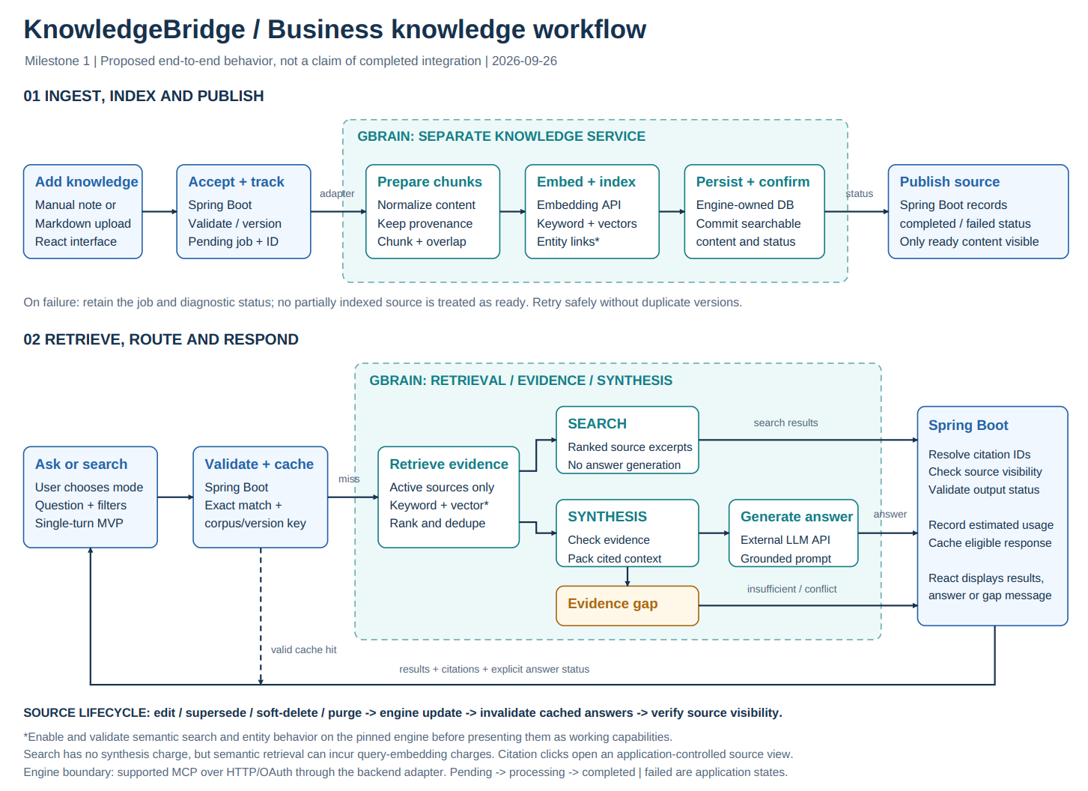
14. 2 System Architecture Diagram
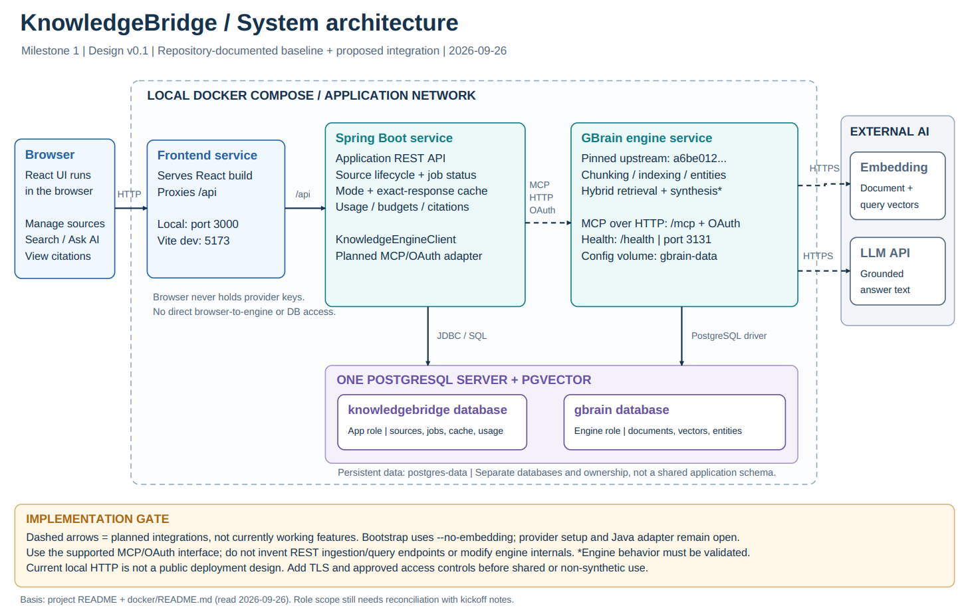
14.3 User Flow Diagram - Main Flow
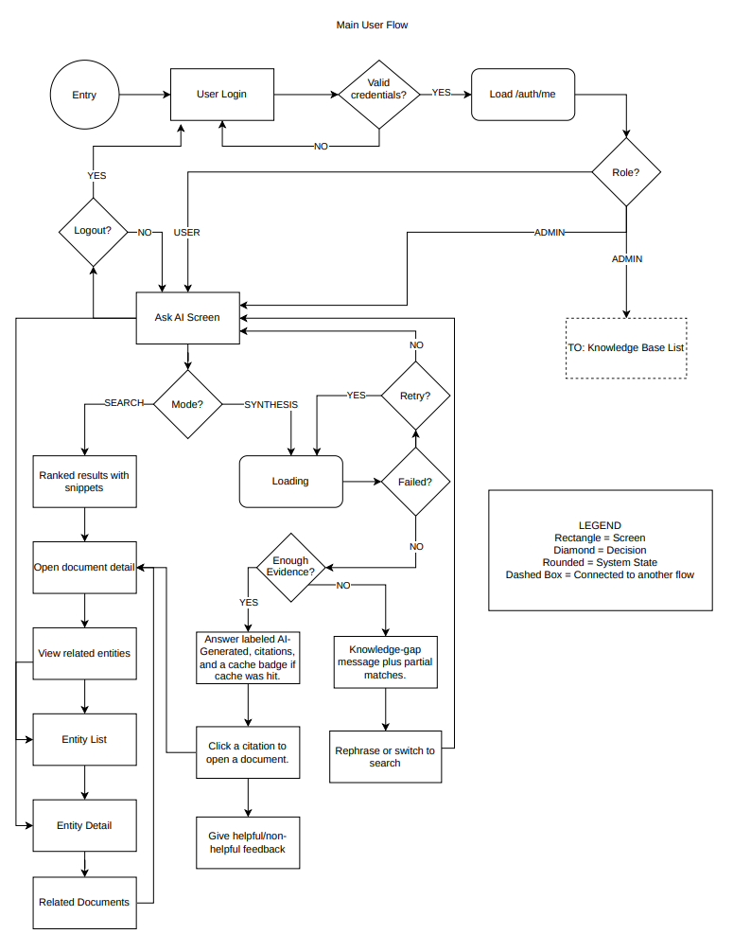
14.4 User Flow Diagram - Admin Usage Dashboard
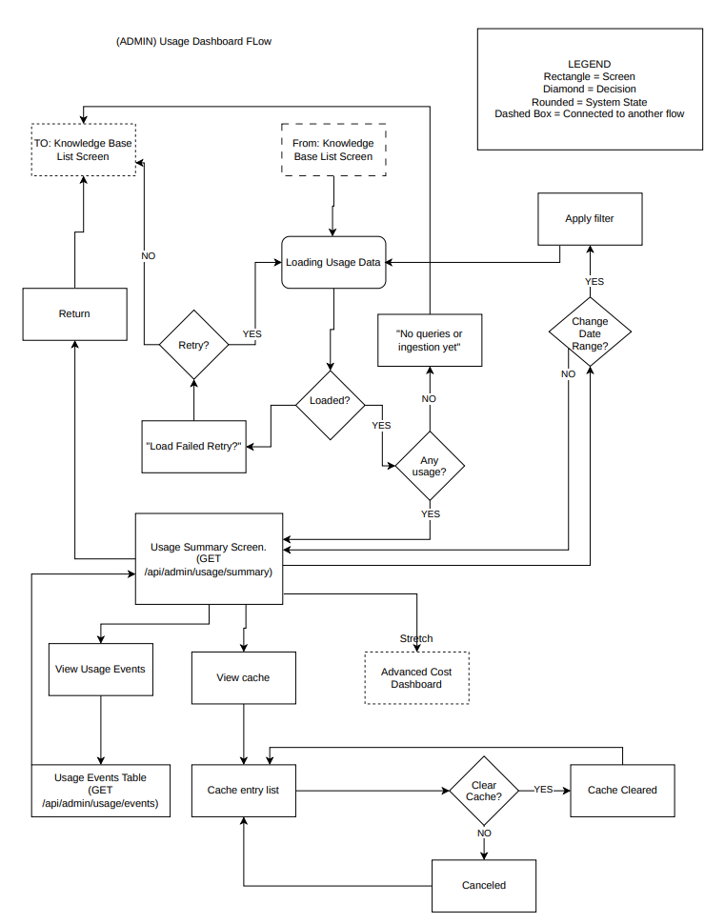
14.5 User Flow Diagram - Admin Management Flow
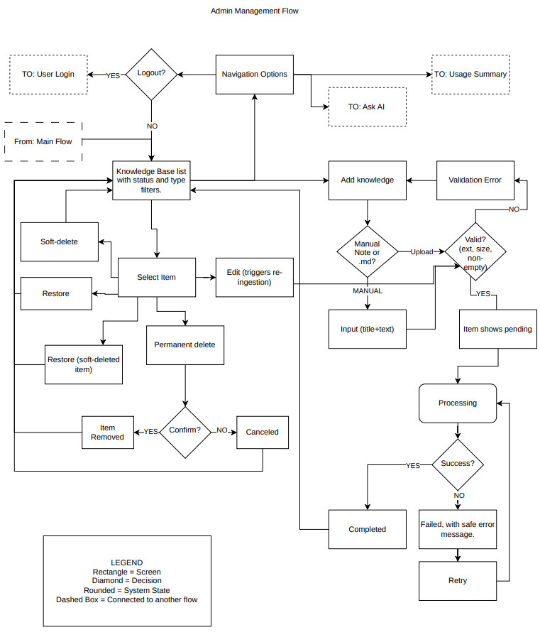
14. 6 Cost Estimate
